LAB 5 – EE450

SESSION 4

Tushar Tiwari

Aim: To observe the variation of the congestion window size with time.

Q1. Reno Flavor

Differences between Reno and Tahoe

1. Tahoe only uses a timeout for detecting congestion, while Reno uses timeout and Fast-Retransmit
2. Tahoe sets the congestion window to 1 after packet loss, while Reno sets it to half of the latest congestion window.

Q2.

*dlow* = 5ms

*dhigh* = 300ms

*llow* = 0

*lhigh* = 0.01

*lmed* = 0.00001

Q3.

*dlow* = 5ms *llow* = 0

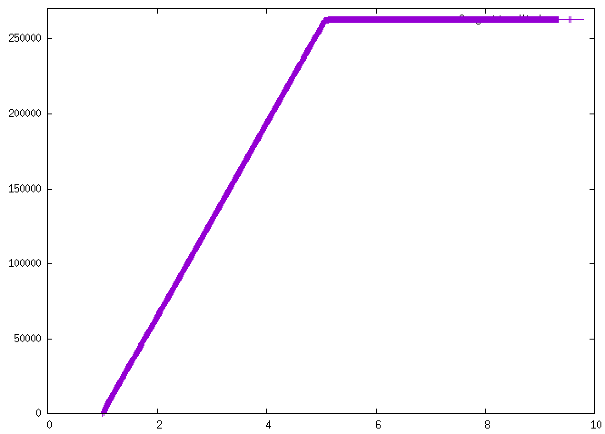

*dlow* = 5ms *lmed* = 0.0001

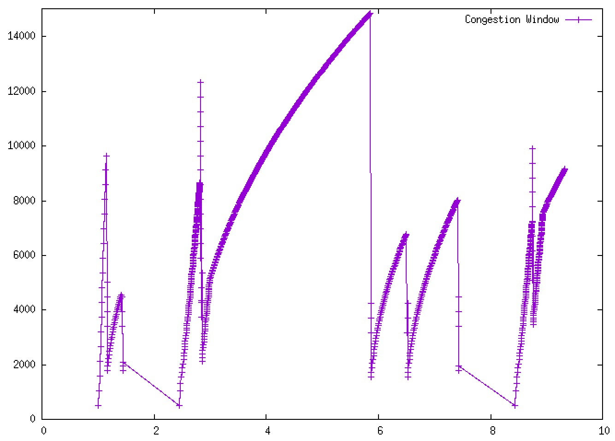

*dlow* = 5ms *lhigh* = 0.01

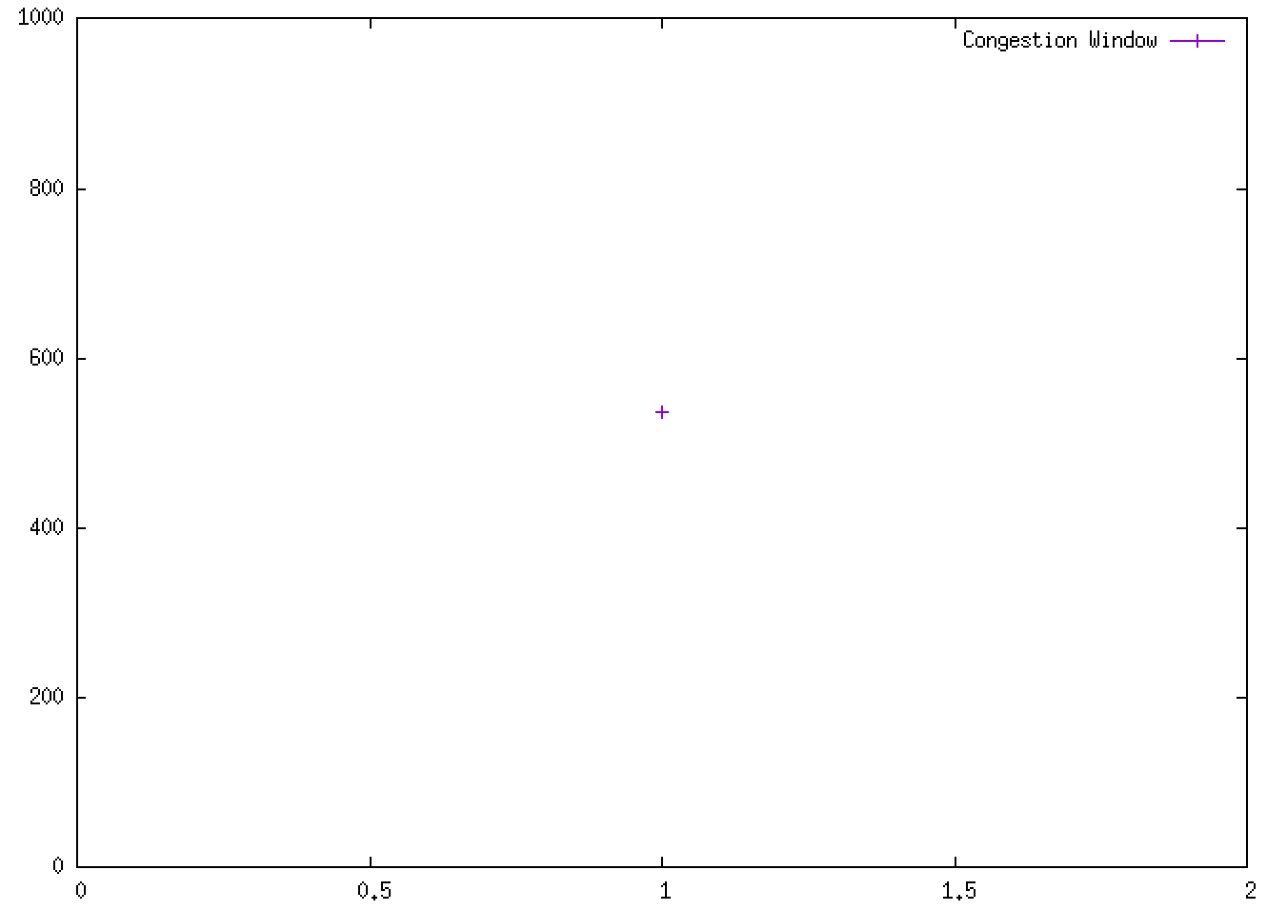

*dhigh* = 300ms *llow* = 0

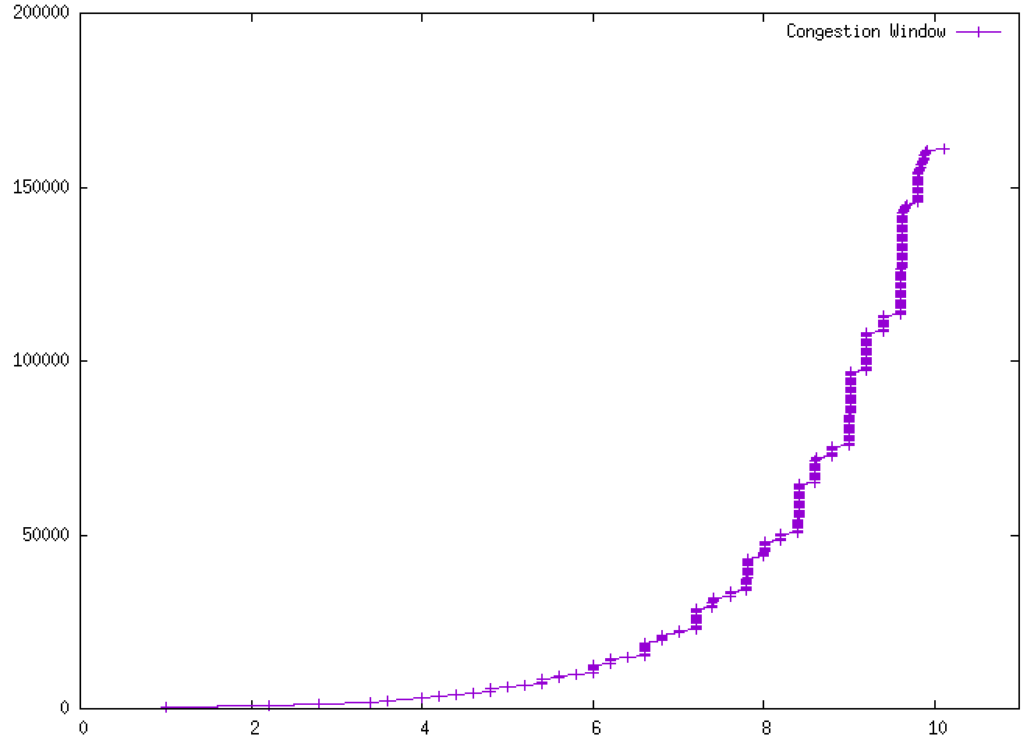

*dhigh* = 300ms *lmed* = 0.0001

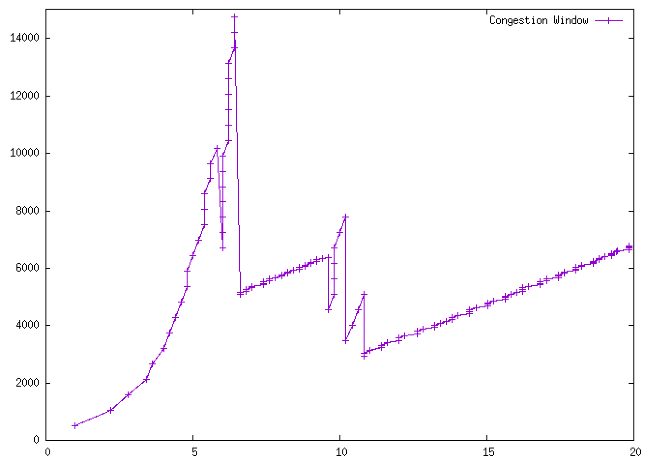

*dhigh* = 300ms *lhigh* = 0.01

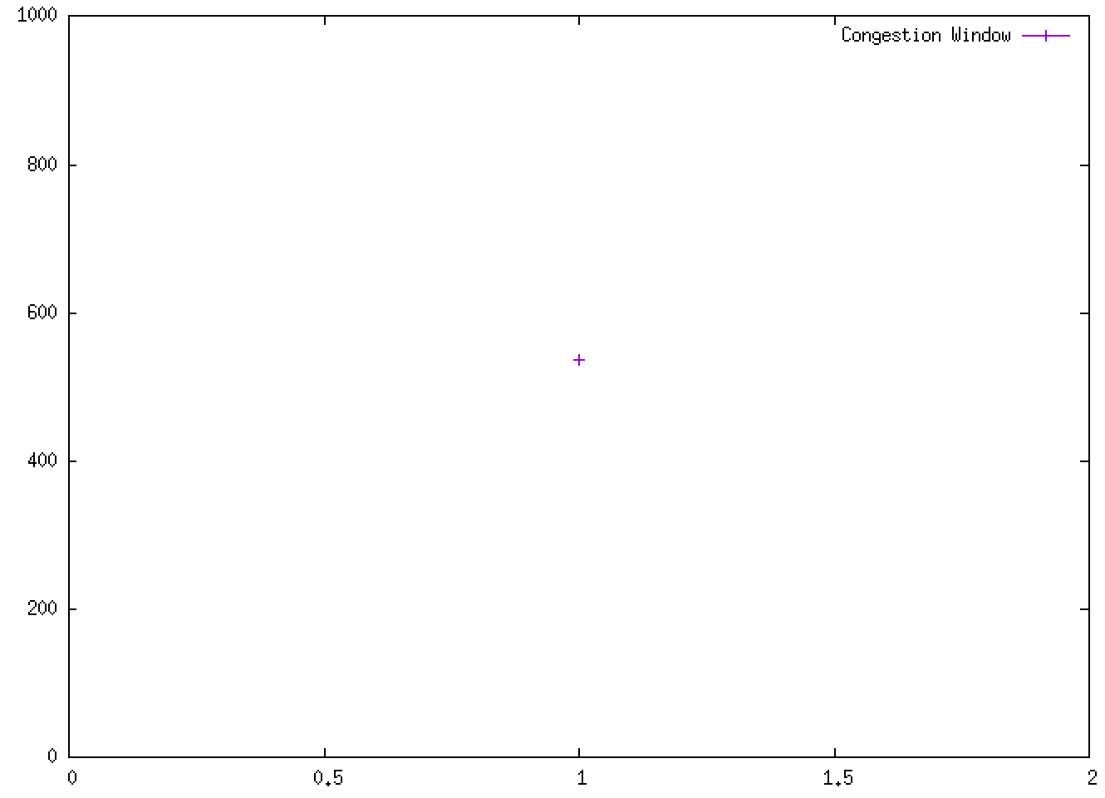

Q4. The salient features in the above plots are:

Slow start: It can be seen in the graph *dhigh, lmed*. In question 1, I have written that this is the reno implementation. This is very clear as it can be seen in the graph of *dhigh* = 300ms *lmed* = 0.0001 that in case of packet loss the CW is not set to 1 but rather half the CW size and also the ssthresh is set to half. Also congestion avoidance can be clearly seen in the graph where CW stops increasing exponentially. Also in *dlow* = 5ms *llow* = 0 the CW goes into Congestion Avoidance very quickly because of no error rates and low latency.

Q5. One very stark difference that jumps right out is the CW rate during the slow start period of of *dlow* = 5ms *lmed* = 0.0001 and *dhigh* = 300ms *lmed* = 0.0001. The CW increases very steeply incase of low delay and increases less steeply incase of more delay due to longer RTTs which should be the expected behavior and thus highlights the difference incase of different delays with same error rates.

Q6. In the case of different error rates for the same delay the obvious difference would be that the size of the congestion window will increase to greater values for lower amounts of error rates. See *dlow* = 5ms *llow* = 0. The CW achieves a high of 25000 whereas in *dlow* = 5ms *lmed* = 0.0001 the CW achieves a high of ~14000 and incase of the highest error rate the packets are dropped so frequently due to the high error rate that the CW never increases beyond one. The error rate is directly proportional to how often timeouts will occur which is again directly proportional to the highest value the CW can achieve. Please note that the single point on the graph denotes that the window was always 1. A similar trend is seen in case of the high delay graphs. This is how my friend can classify the plots.

Q7. t = 8.73, 7.43, 7.40, 6.49, 5.84, 2.8, 2.81, 2.82, 1.44, 1.40, 1.13

Conclusion: This lab improved my understanding of how the CW size changes because of network factors delay and error rate.